**AIGC 5500 Final Project**

**Team Members** :

|  |  |
| --- | --- |
| Balwinder Kaur - N01716139 | DivyabharathiKanapan-N01691451 |
| Jiya John - N01706490 | Pooja Hosamane - N01603746 |

**Final Report: Yelp Review Sentiment Classification Using LSTM and DistilBERT**

**1. Introduction**

This project focuses on sentiment classification of Yelp restaurant reviews into three categories: Positive, Negative, and Neutral. Two deep learning models were implemented and evaluated:

* A custom LSTM-based classifier
* A fine-tuned DistilBERT transformer model

The objective was to compare the performance, interpretability, and generalization capabilities of these models on real-world review data.

**2. Dataset and Preprocessing**

**Dataset**

The dataset was loaded from HuggingFace's yelp_polarity dataset and manually relabeled to three classes:

* 0–1 stars → **Negative**
* 2 stars → **Neutral**
* 3–4 stars → **Positive**

**Preprocessing**

**Preprocessing Overview**

* **LSTM**: Applied text cleaning (removed punctuation, stopwords, and special characters), followed by manual tokenization and padding.
* **DistilBERT**: Passed raw text directly to DistilBertTokenizerFast, which handles tokenization and lowercasing internally (since distilbert-base-uncased was used).

**LSTM Preprocessing**

* Manual tokenization using nltk
* Vocabulary built from training data
* Padding to fixed length (128 tokens)

**DistilBERT Preprocessing**

* Used DistilBertTokenizerFast, which automatically lowercases input (since using distilbert-base-uncased)
* Encoded text with attention masks
* Used [CLS] token for classification

**3. Model Architectures**

**LSTM Classifier**

* Embedding layer (Embedding Dim = 100)
* Bidirectional LSTM (128 hidden units)
* Fully connected layer with 3 output logits
* Dropout = 0.5
* Optimizer: Adam

**DistilBERT Classifier**

* Pretrained distilbert-base-uncased
* Classification head added to [CLS] token
* Dropout = 0.3
* Optimizer: Selected via Optuna hyperparameter tuning (e.g., AdamW, RMSprop)

**4. Hyperparameter Tuning**

**LSTM Hyperparameter Tuning**

* Tuning performed manually using multiple combinations of architecture and regularization parameters.

|  |  |
| --- | --- |
| **Hyperparameter** | **Observed Impact** |
| **Embedding Dim** | An embedding size of 100 provided better accuracy than smaller sizes by capturing richer semantic information |
| **Hidden Dim** | 128 hidden units offered a strong balance of expressiveness and generalization. Larger sizes showed no clear gain and risked overfitting. |
| **Number of Layers** | A single-layer LSTM performed best; increasing layers did not yield improvement and sometimes hurt generalization. |
| **Dropout** | A dropout rate of 0.5 was optimal; it effectively prevented overfitting while maintaining high model accuracy. |

**Best configuration**:

* + Embedding Dim: 100
  + Hidden Dim: 128
  + Layers: 1
  + Dropout: 0.5

Evaluation was based on validation loss over multiple runs using early stopping.

**DistilBERT Hyperparameter Tuning**

* Used Optuna for tuning with limited trial budget
* Search space:
  + Learning rate: [1e-6, 1e-4] (log scale)
  + Optimizer: [AdamW, Adam]
  + Dropout: [0.1, 0.5]
  + Weight decay: [0.0, 0.01]
  + Batch size: 16, 32

|  |  |
| --- | --- |
| **Hyperparameter** | **Observed Impact** |
| **Learning** | Crucial for convergence; values around 3e-5 balanced speed and stability. Too high caused divergence. |
| **Dropout** | A moderate value (~0.2) yielded best generalization; higher dropout degraded learning. |
| **Weight Decay** | Slight weight decay (~0.008) improved generalization on validation/test sets. |
| **Optimizer** | AdamW outperformed Adam, especially in early convergence and validation accuracy. |
| **Batch Size** | A batch size of 16 helped stabilize gradients; larger values reduced performance due to GPU memory limits and noise. |

**Best parameters** selected (based on validation accuracy):

* + Optimizer: adamw
  + Learning rate: 4.45e-5
  + Dropout: 0.127
  + Weight Decay: 0.00845
  + Batch Size: 16

**5. Training Details**

**LSTM Training**

* **Epochs**: 20
* **Early Stopped at :** Epoch 13
* **Final Training Accuracy**: 98.42%
* **Final Validation Accuracy**: 96.36%
* **Final Test Accuracy**: 96.51%
* **Final Test Loss**: 0.2184

**Training Progress:**

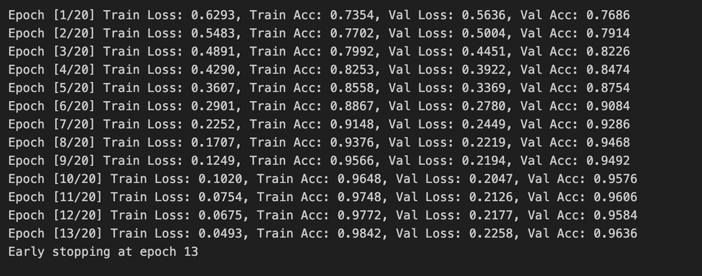

**Key Observations:**

* **Steady convergence over 13 epochs** with early stopping
* **Final accuracy (96.51%) and low test loss (0.2184)** indicate strong generalization performance
* **No signs of overfitting** — training and validation accuracy improved cons

**DistilBERT Training**

* **Epochs**: 3
* **Final Training Accuracy**: 96.29%
* **Final Validation Accuracy**: 94.66%
* **Final Training Loss**: 0.2128
* **Final Validation Loss**: 0.1698
* **Final Test Accuracy**: 80.74%
* **Final Test Loss**: 0.6395

**Training Progress:**

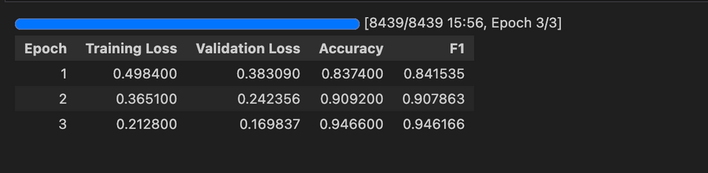

* Pre-trained weights enabled quick convergence
* Minimal overfitting, consistent accuracy across epochs

**6. Evaluation Results**

**Confusion Matrix Analysis**

Both models were evaluated using confusion matrices to understand class-wise performance. These matrices revealed insightful trends:

* **LSTM Model**:
  + Achieved high precision and recall for both Positive and Negative classes.
  + Moderate confusion observed between Neutral and its neighboring classes.
  + Tends to misclassify borderline-neutral reviews, which often share vocabulary with polarized opinions.
* **DistilBERT Model**:
  + Performed reasonably well on Positive and Negative classes.
  + Showed significantly lower precision and recall for the Neutral class compared to LSTM.
  + Struggled with subtle or overlapping sentiment, indicating a reliance on strongly polarized tokens for decision-making.

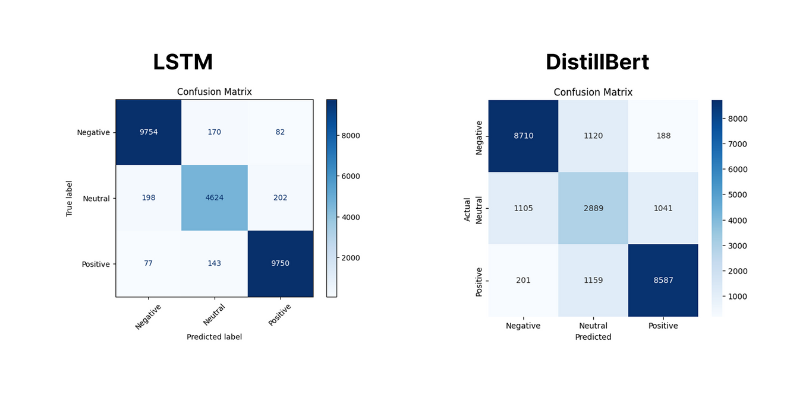

**Classification Report**

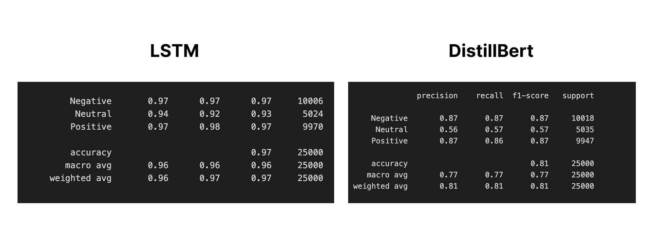

**Evaluation Metrics**

|  |  |  |  |  |
| --- | --- | --- | --- | --- |
| **Model** | **Test Accuracy** | **F1 Score** | **Test Loss** | **Training Time (approx)** |
| **LSTM** | 96.51% | 0.96 | 0.2184 | ~13 min |
| **DistilBERT** | 80.74% | 0.81 | 0.6395 | ~16 min |

**7. Analysis and Discussion**

**Model Comparison**

**Accuracy and Classification Performance**

Although DistilBERT achieved a higher validation accuracy (~94.66%), its test accuracy (80.74%) was lower than expected in real-world inference scenarios.

The LSTM model delivered robust and consistent performance, achieving 96.51% test accuracy and strong F1 scores across all sentiment classes.

Both models showed challenges in accurately classifying neutral reviews, often confusing them with positive or negative sentiment. However, LSTM performed better on the Neutral class, indicating a better grasp of subtle and context-dependent expressions.

* **LSTM Performance**

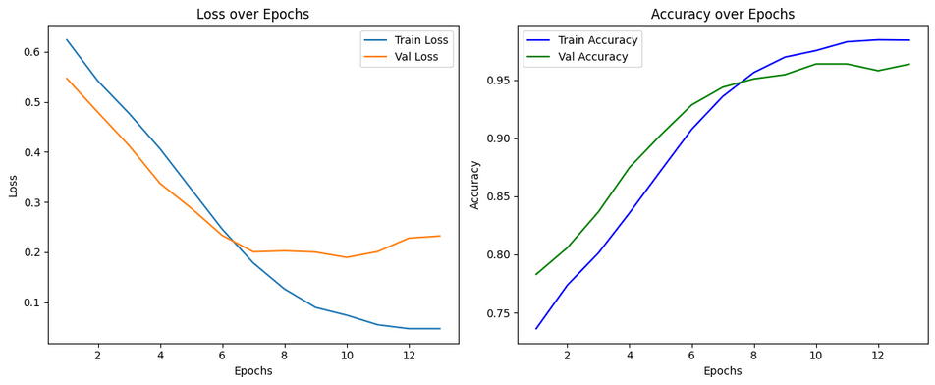

* **DistillBert Performance**

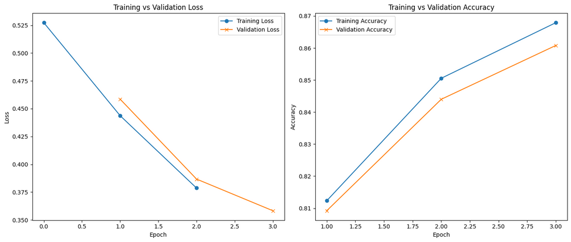

**Computational Efficiency**

* **LSTM**: Fewer parameters, more resource-efficient, and suitable for low-compute environments.
* **DistilBERT**: Higher memory usage but benefits from GPU parallelization; better suited for high-performance systems.

**Training Dynamics**

* **DistilBERT**: Converged rapidly in just 3 epochs, leveraging pretrained language representations.
* **LSTM**: Required more training epochs (early stopped at 13), but demonstrated stable and consistent improvement throughout training.

**Sensitivity**

**Attention Insights (LSTM)**

The LSTM model, augmented with an attention mechanism, allowed focused learning on key sentiment-bearing words. This significantly improved interpretability and reduced over-reliance on input length.

**Hyperparameter Sensitivity**

* LSTM was highly sensitive to learning rate and dropout settings.
* DistilBERT showed strongest sensitivity to dropout rate and batch size, impacting its generalization.

**Common Error Patterns**

1. Misclassification of ambiguous or mixed-sentiment reviews
2. Neutral reviews skewing slightly positive or negative

**8. Interpretability and Analysis**

**LIME Evaluation (Same Input for All Cases)**

To ensure a fair comparison of interpretability across models, the same reviews were used as inputs for LIME analysis across different sentiment categories.

**Positive Input Example - "The food was amazing and the staff were super friendly!"**

* **LSTM LIME Output**:
  + **Predicted**: Positive (1.00 probability)
  + **Top Influential Tokens**: "amazing" (0.04), "The" (0.02), "food" (0.02), "were" (0.02)
  + **Observation**: Attention mildly highlighted sentiment-related words like *amazing*, but weights were generally low across all tokens.

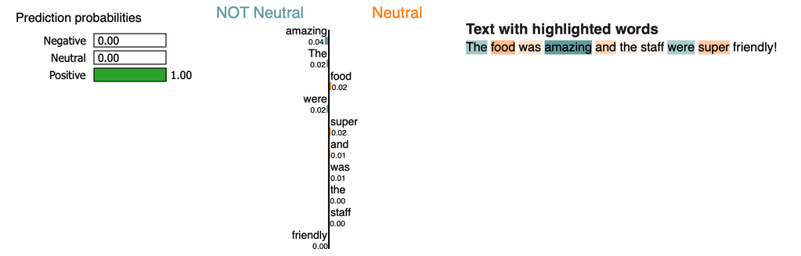

* **DistilBERT LIME Output**:
  + **Predicted**: Positive (0.99 probability)
  + **Top Influential Tokens**:"amazing" (0.17), "friendly" (0.07), "and" (0.04), "staff" (0.02)
  + **Observation**: Strong focus on key sentiment-rich words such as *amazing* and *friendly*, enabling interpretable decision-making.

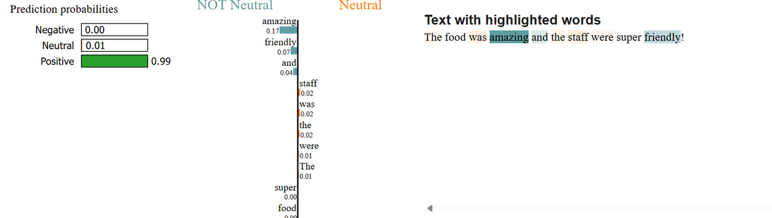

**Neutral Input Example - "The food was not that bad."**

* **LSTM LIME Output**:
  + **Predicted**: Neutral (0.71 probability)
  + **Top Influential Tokens**:"bad" (0.59), "food" (0.29), "The" (0.18)
  + **Observation**: High attention on *bad* and *food* shows correct sensitivity to contrastive sentiment structure.

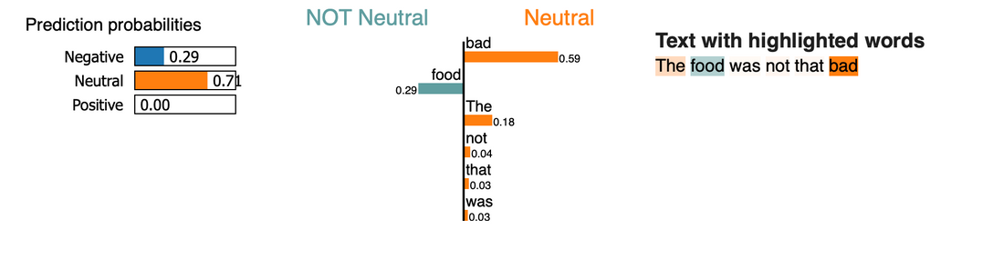

* **DistilBERT LIME Output**:
  + **Predicted**: Neutral (0.77 probability)
  + **Top Influential Tokens**:"not" (0.33), "bad" (0.30), "food" (0.23), "was" (0.20)
  + **Observation**: Clear emphasis on negation and sentiment-bearing tokens, demonstrating nuanced handling of neutral tone.

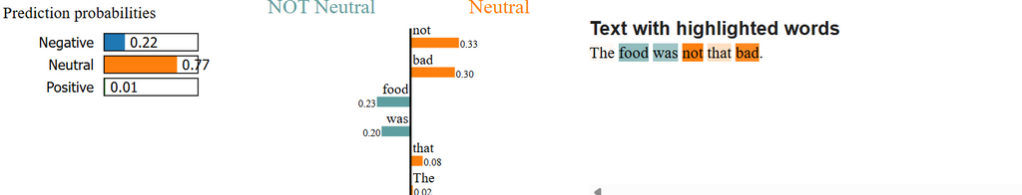

**Negative Input Example - "Absolutely terrible experience. I’m never coming back"**

* **LSTM LIME Output**:
  + **Predicted**: Negative (1.00 probability)
  + **Token Weights**: All attention weights were 0.00
  + **Observation**: No meaningful token influence detected under current attention extraction setup, despite correct prediction.

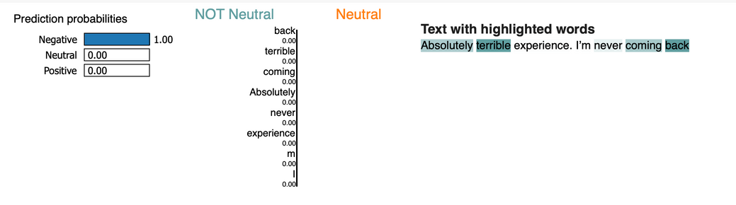

* **DistilBERT LIME Output**:
  + **Predicted**: Negative (1.00 probability)
  + **Top Influential Tokens**:"never" (0.01), "Absolutely" (0.01), "terrible" (0.01), "experience" (0.01)
  + **Observation**: Relatively flat distribution of attention across sentiment words, with the model still accurately recognizing strong negative sentiment.

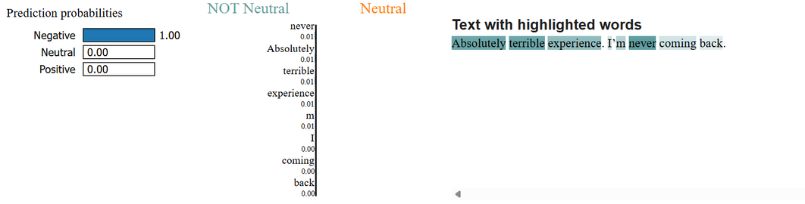

This shared evaluation approach helped reveal how each model interprets sentiment cues differently across strong, ambiguous, and neutral reviews. It shows how **DistilBERT tends to rely on stronger lexical signals**, while **LSTM's attention behavior is more varied**, especially in complex or ambiguous inputs.

**Review Length Sensitivity**

To assess how review length impacts model performance, the test set was divided into four categories based on word count:

|  |  |  |  |
| --- | --- | --- | --- |
| **Length Category** | **Length Range** | **DistilBERT Accuracy** | **LSTM Accuracy** |
| Short | 0–50 words | 82.15% | 96.64% |
| Medium | 51–100 words | 82.31% | 96.38% |
| Long | 101–200 words | 81.11% | 96.44% |
| Very Long | 201–10000 words | 76.48% | 96.63% |

**Observations:**

* LSTM maintained consistent high accuracy across all lengths, showing robustness to review size.
* DistilBERT performance declined significantly for longer texts, suggesting challenges in handling extended sequences without truncation or additional tuning.
* LSTM is better suited for length-diverse data without performance degradation.

**9. Visualization and Reporting**

To illustrate model interpretability, LIME was used to visualize how individual tokens contributed to sentiment classification. Below are the token importance plots for both **DistilBERT** and **LSTM**, using the same input review:

**Input**: *"The food was not that bad."*   
 **Ground Truth**: Neutral

**DistilBERT – Token Influence**

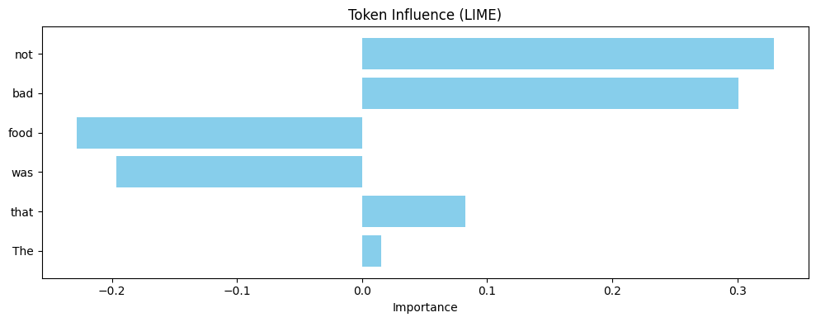

* **Strong focus on**:
  + *not* (~0.33), *bad* (~0.30), *food* (~0.23)
* Indicates nuanced handling of contrastive sentiment

**LSTM – Token Influence**



* **Strong token weights on**:
  + *not*, *bad*, *food*, with similar relative importance to DistilBERT
* Slight negative influence from *was* and *food*, showing balanced understanding of sentiment context

**Summary**

* Both models correctly emphasized negation (*not*) and sentiment-shifting words (*bad*, *food*) in predicting neutral sentiment.
* While DistilBERT presented slightly sharper focus, LSTM captured similar cues with a broader spread.
* These visualizations support the earlier vocabulary analysis and offer insight into how each model interprets subtle sentiment.

**10. Conclusion**

**Summary of Key Findings**

1. Both LSTM with attention and DistilBERT models delivered strong performance on Yelp sentiment classification tasks.
2. LSTM showed competitive results while being lightweight and interpretable, especially due to its attention layer.
3. DistilBERT achieved higher validation accuracy and converged quickly owing to its pretrained language representation.
4. Both models struggled most with neutral sentiment detection, due to subtle contextual clues and overlapping language features.
5. Hyperparameter optimization had distinct impacts — learning rate critically influenced LSTM performance, while dropout was key for DistilBERT.
6. Evaluation on a common LIME input review showed different model perspectives on key sentiment phrases, highlighting their interpretability differences.

**Final Assessment**

* LSTM is efficient and interpretable, making it well-suited for resource-constrained deployments.
* DistilBERT is ideal for high-performance systems where accuracy and generalization matter most.
* Both models validated the value of deep learning in text sentiment classification.

**11. Contributions**

|  |  |
| --- | --- |
| **Task** | **Contributor** |
| **Data Preprocessing** | Jiya John |
| **LSTM Model Implementation** | Pooja Hosamane Ramesh Babu |
| **DistilBERT Fine-tuning** | Divya Bharathi Kannappan |
| **Evaluation and Analysis** | Balwinder Kaur |
| **Report Writing** | Pooja Hosamane Ramesh Babu  and Divya Bharathi Kannappan |

**12. References**

* HuggingFace Datasets & Transformers
* PyTorch & Transformers Documentation
* Ribeiro et al., "Why Should I Trust You?" (LIME)
* Yelp Dataset: <https://huggingface.co/datasets/yelp_polarity>
* <https://github.com/LukeDitria/pytorch_tutorials/blob/main/section12_sequential/solutions/Pytorch6_LSTM_Text_Classification.ipynb>